Fast and Processor Efficient Parallel Matrix Multiplication Algorithms on a Linear Array With a Reconfigurable Pipelined Bus System
Keqin Li, Yi Pan, and Si Qing Zheng
IEEE Transactions on parallel and distributed systems, VOL. 9, No.8, p.705~720 (1998.8)
Abstract
Present efficient parallel matrix multiplication algorithms for linear arrays with reconfigurable pipelined bus systems (LARPBS).

1. Introduction
2. Linear Arrays With Reconfigurable Pipelined Bus Systems and Coincident Pulse Processor Addressing Technique
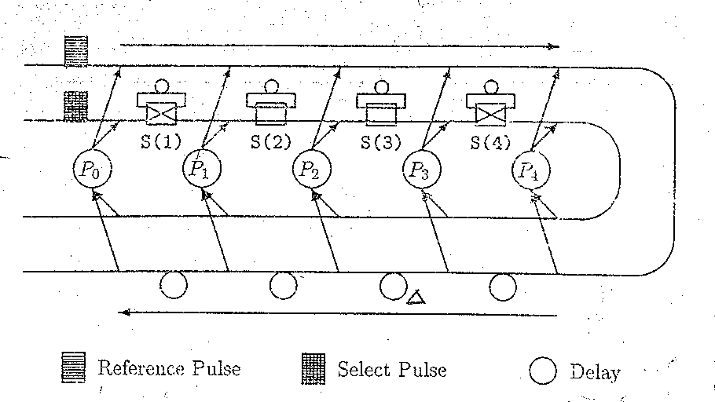
An optical bus

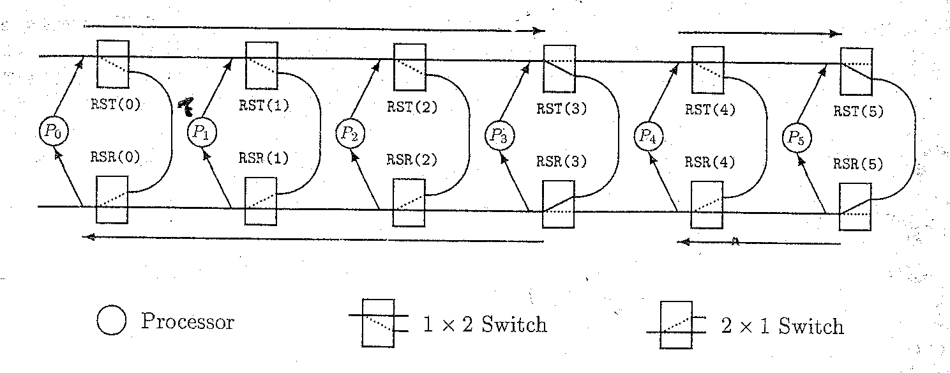
An LARPBS with two subarrays

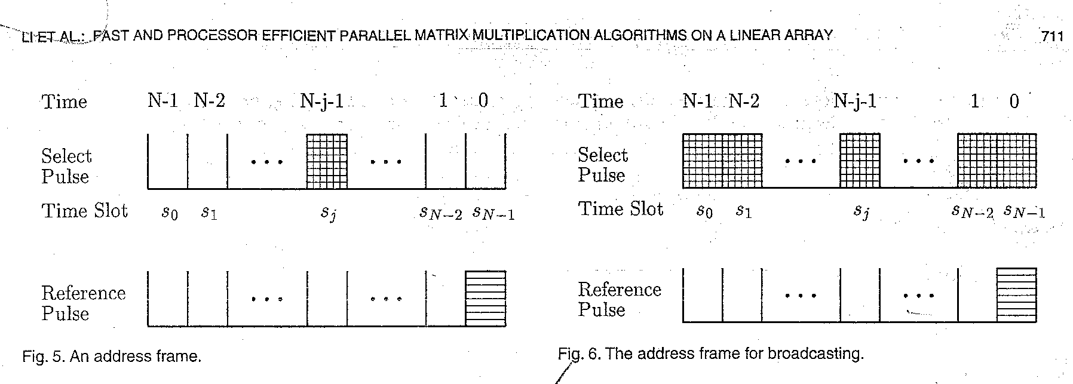

Suppose processor Pi wants to send a message to processor Pi
1. t_{sel}(j) = t_{ref} + ( N – j –1)ω,
2. t_{i,j} = t_{ref} + (N – 1 – i )τ + (N – j ) τ+ (N – 1 – j ) ω
= t_{sel}(j) + (2N – i – j – 1)τ,
ω: the duration in seconds of a single optical pulse;
τ: pipeline cycle, i.e., the time for an optical pulse to travel the section between two consecutive processors
3. Primitive Operations
3.1 One-to-One Communication
3.2 Broadcasting
3.3 Multiple Multicasting
3.4 Element Pair-Wise Operations
3.5 Binary Prefix Sums
3.6 Extraction and Compression
3.7 Binary Value Aggregation
3.8 Boolean Value Aggregation
3.9 Integer Aggregation
3.10 Floating-Point Value Aggregation

4. Matrix Multiplication
MM₁：An O(N) algorithm using N² processors
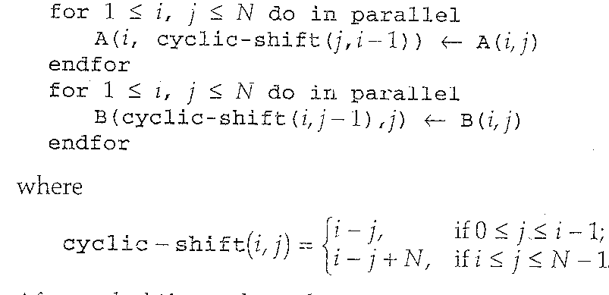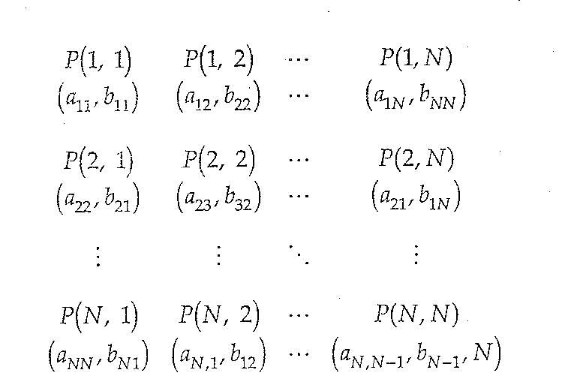
MM₂：An O(1) algorithm using N³ processors
MM₃： An O(logN) algorithm using O(N^{2.8074}) processors.
Strassen’s recursive method.
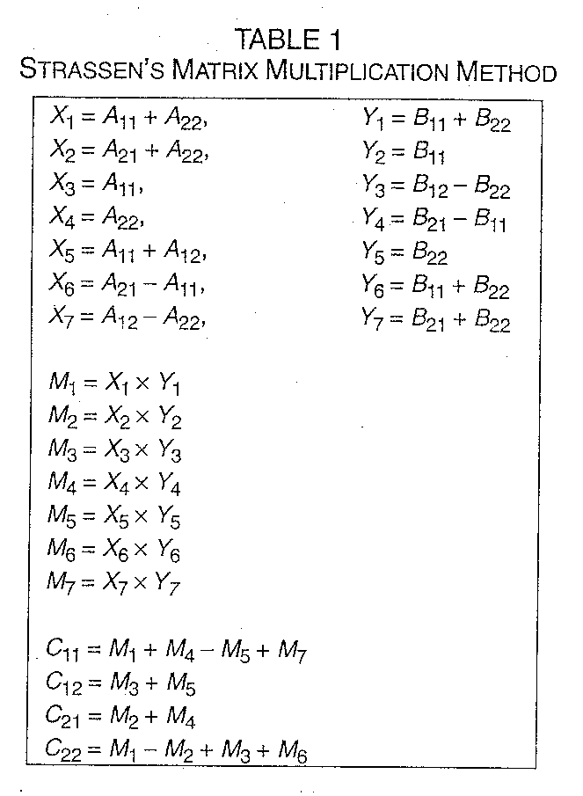
5. Compound Algorithms
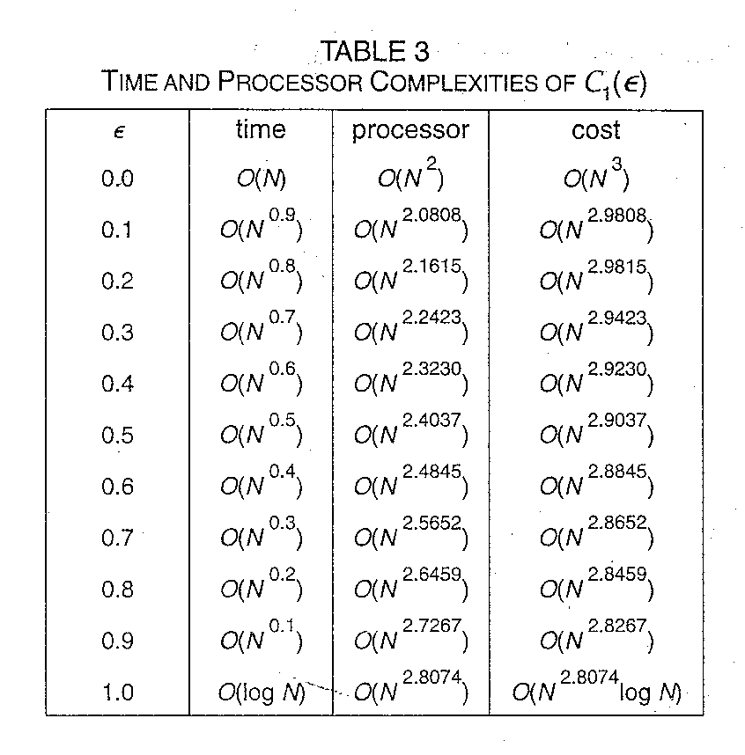
Created by: Ming-Cheng Lin
Date: Dec. 10, 1999

